*Four Letter Words* is a simple puzzle game with the challenge of changing one four letter word into another four letter word one letter at a time.

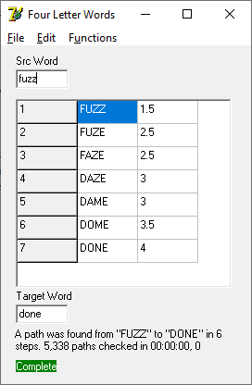

After entering the source (*Src Word*) word and the target word (*Target Word)* press ^P (Find Path to Target) to see if a path between the two can be found.

It is also possible to generate a list of words like the *Src Word* by pressing ^W (Find Similar Words).

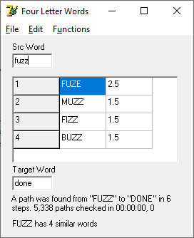

It is also to build a file of words that have no one letter difference connections to any other words or a file of words that have the maximum possible one letter difference connections to other words. These options are in the *Functions* menu.